COP 4710 – Database Systems – Fall 2013

Homework #1 – 100 points -
KEY

Due: Thursday September 12, 2013 by 11:55 pm NO LATE ASSIGNMENTS ACCEPTED

Answer each of the following questions completely. Make sure that your answers are neatly written and very readable. Points will be deducted if your assignment is not presented in a neat format. Submit your assignment via WebCourses.

- (35 points total)
Given the E-R diagram (ERD) shown below, provide answers for (a)-(c).
- (10 points) Write the explicit cardinalities (i.e., UML style) indicated by the crow’s foot notation used in the ERD.
- (20 points) Write all of the business rules reflected by this ERD.
- (5 points) Describe precisely the composition of the DEPENDENT weak entity’s primary key.

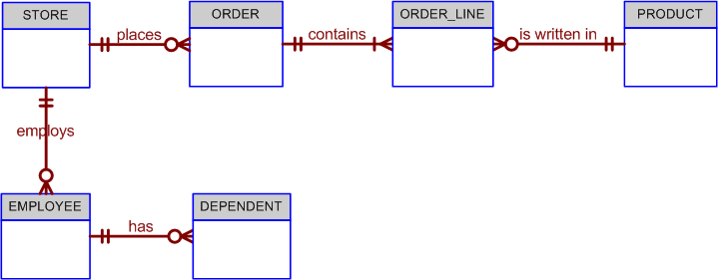

(a)
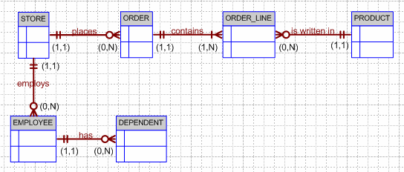

(b)
The following business rules are reflected in the ERD:
- A store may place many orders. (Note the use of “may” – which is reflected in the ORDER optionality.)
- An order must be placed by a store. (Note that STORE is mandatory to ORDER. In this ERD, the order environment apparently reflects a wholesale environment.)
- An order contains at least one order line. (Note that ORDER_LINE is mandatory to ORDER, and vice-versa.)
- Each order line is contained in one and only one order. (Discussion: Although a given item – such as a hammer – may be found in many orders, a specific hammer sold to a specific store is found in only one order.)
- Each order line has a specific product written in it.
- A product may be written in many orders. (Discussion: Many stores can order one or more specific products, but a product that is not in demand may never be sold to a store and will, therefore, not show up in any order line -- note that ORDER_LINE is optional to PRODUCT. Also, note that each order line may indicate more than one of a specific item. For example, the item may be “hammer” and the number sold may be 1 or 2, or 500. The ORDER_LINE entity would have at least the following attributes: ORDER_NUM, ORDLINE_NUM, PROD_CODE, ORDLINE_PRICE, ORDLINE_QUANTITY. The ORDER_LINE composite PK would be ORDER_NUM + ORDLINE_NUM. You might add the derived attribute ORDLINE_AMOUNT, which would be the result of multiplying ORDLINE_PRICE and ORDLINE_QUANTITY.)
- A store may employ many employees. (Discussion: A new store may not yet have any employees, yet the database may already include the new store information … location, type, and so on. If you made the EMPLOYEE entity mandatory to STORE, you would have to create an employee for that store before you had even hired one.)
- Each employee is employed by one (and only one) store.
- An employee may have one or more dependents. (Discussion: You cannot require an employee to have dependents, so DEPENDENT is optional to EMPLOYEE. Note the use of the word “may” in the relationship.)
- A dependent must be related to an employee. (Discussion: It makes no sense to keep track of dependents of people who are not even employees. Therefore, EMPLOYEE is mandatory to DEPENDENT.)

(c)
The DEPENDENT entity will have a composite primary key (PK) that includes the EMPLOYEE entity’s PK and one of its attributes. For example, if the EMPLOYEE entity’s PK is EMP_NUM, the DEPENDENT entity’s PK might be EMP_NUM + DEP_NUM.

- (15 points)
Construct a Crow’s foot ERD for the scenario described by the following set of business rules. . Write all appropriate connectivities and cardinalities in the ERD.

Hot Water (HW) is a small start-up company that sells spas. HW does not carry any stock. A few spas are set up in a simple warehouse so customers can see some of the models available, but any products sold must be ordered at the time of the sale.
- HW can get spas from several different manufacturers.
- Each manufacturer produces one or more different brands of spas.
- Each and every brand is produced by only one manufacturer.
- Every brand has one or more models.
- Every model is produced as part of a brand. For example, Iguana Bay Spas is a manufacturer that produces Big Blue Iguana spas, a premium-level brand, and Lazy Lizard spas, an entry-level brand. The Big Blue Iguana brand offers several models, including the BBI-6, an 81-jet spa with two 6-hp motors, and the BBI-10, a 102-jet spa with three 6-hp motors.
- Every manufacturer is identified by a manufacturer code. The company name, address, area code, phone number, and account number are kept in the system for every manufacturer.
- For each brand, the brand name and brand level (premium, mid-level, or entry-level) are kept in the system.
- For each model, the model number, number of jets, number of motors, number of horsepower per motor, suggested retail price, HW retail price, dry weight, water capacity, and seating capacity must be kept in the system.

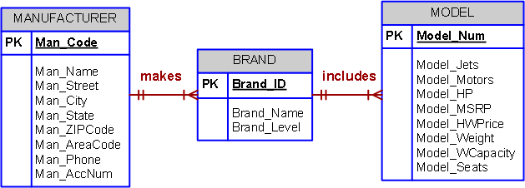

3. (25 points)
(a) Create a Crow’s foot ERD that correctly depicts the following requirements:
- An INVOICE is written by a SALESREP. Each sales representative can write many invoices, but each invoice is written by a single sales representative.
- The INVOICE is written for a single CUSTOMER. However, each customer can have many invoices.
- An INVOICE can include many detail lines (LINE), each of which describes one product bought by the customer.
- The product information is stored in a PRODUCT entity.
- The product’s vendor information is found in a VENDOR entity
The ERD must reflect business rules that you are free to define (within reason). Make sure that your ERD reflects the conditions you require. Finally, make sure that you include the attributes that would permit the model to be successfully implemented.

- Describe how your ERD might change depending on the assumptions you made in your business rules.

(a)
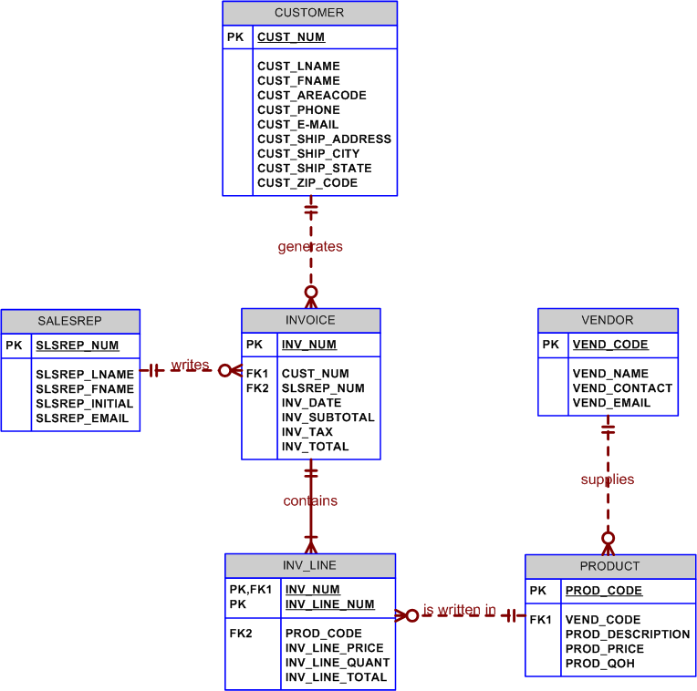

(b)
Keep in mind that the preceding ER diagram reflects a set of business rules that may easily be modified. For example, if customers are supplied via a commercial customer list, many of the customers on that list will not (yet!) have bought anything, so INVOICE would be optional to CUSTOMER. We are assuming here that many vendors can supply a product and that each vendor can supply many products. The PRODUCT may be optional to VENDOR if the vendor list includes potential vendors from which you have not (yet) ordered anything. Some products may never sell, so LINE is optional to PRODUCT... because an unsold product will never appear in an invoice line. You may also want to show the students how the composite entities may be represented at the final implementation level. For example, LINE is shown as weak to INVOICE, because it borrows the invoice number as part of its primary key and it is existence-dependent on INVOICE. The modified ER diagram is shown next. The point of this exercise is that the design's final iteration depends on the exact nature of the business rules and the desired level of implementation detail.

4. (25 points)
The FlyRight Aircraft Maintenance (FRAM) division of the FlyRight Company (FRC) performs all maintenance for FRC’s aircraft. Assume the following business rules reflect how FRC goes about its business:
- All mechanics are FRC employees. Not all employees are mechanics.
- Some mechanics are specialized in engine (EN) maintenance. Some mechanics are specialized in airframe (AF) maintenance. Some mechanics are specialized in avionics (AV) maintenance. (Avionics are the electronic components of an aircraft that are used in communication and navigation.) All mechanics take periodic refresher courses to stay current in their areas of expertise. FRC tracks all course taken by each mechanic—date, course type, certification (Y/N), and performance.
- FRC keeps a history of the employment of all mechanics. The history includes the date hired, date promoted, date terminated, and so on. (Note: The “and so on” component is, of course, not a real-world requirement. Instead, it has been used here to limit the number of attributes you will show in your design.)

Given those requirements, create a Crow’s Foot ERD that accurately depicts this scenario.

